Question 2 [6 Points]
You are given a log file containing entries in the format:
YYYY-MM-DD HH:MM:SS LEVEL MESSAGE
Example:
2025-01-12 10:15:22 INFO System started
2025-01-12 10:16:01 ERROR Disk not found
2025-01-12 10:16:45 WARNING High memory usage
2025-01-12 10:17:10 ERROR Network timeout
Requirements:
1. The script must accept the log file name as a command-line argument.
2. Validate that the file exists and is readable.
3. Count and display:
- Total number of log entries
- Number of INFO, WARNING, and ERROR messages
4. Display the most recent ERROR message.
5. Generate a report file named logsummary_<date>.txt.
6. Handle errors gracefully with meaningful messages.
------

Answer
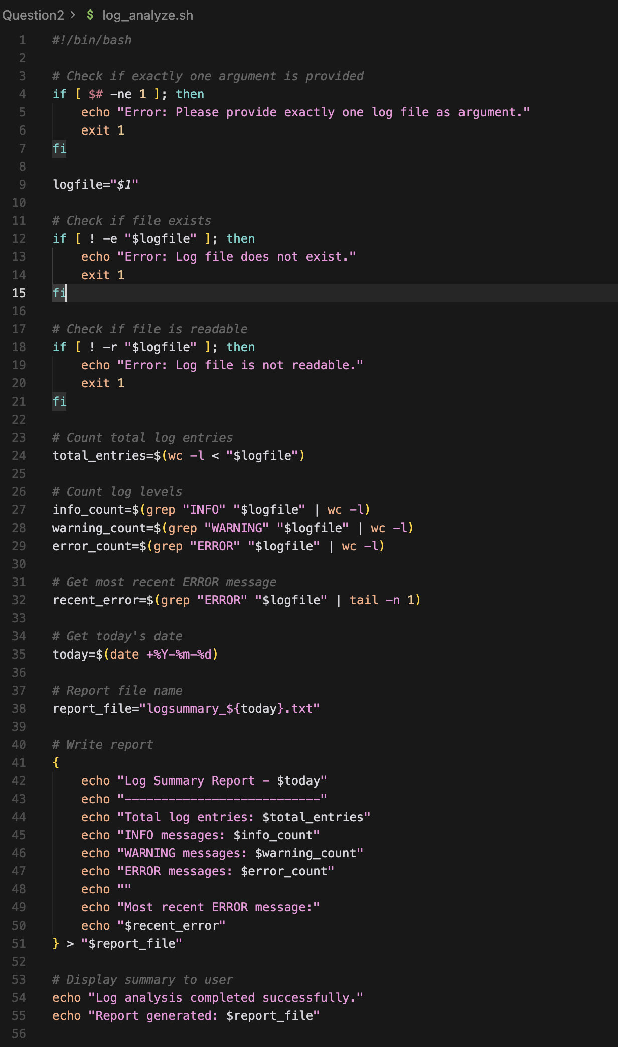
I have already explained the basics in the previous answer 1.
logfile="$1" : Store the log file name in a variable called logfile.
if [ ! -e "$logfile" ]; then : If the file does NOT exist
info_count=$(grep "INFO" "$logfile" | wc -l) : Count INFO log messages
recent_error=$(grep "ERROR" "$logfile" | tail -n 1) : Get the most recent ERROR messages
today=$(date +%Y-%m-%d) : Print today's date in required format.
----
The script pareses a log file file using grep and wc ,extracts the most rectn ERROR using tail, and generates a dated summary report with proper validation.
----
Output from the terminal:

